Health and Wellbeing
POLICY
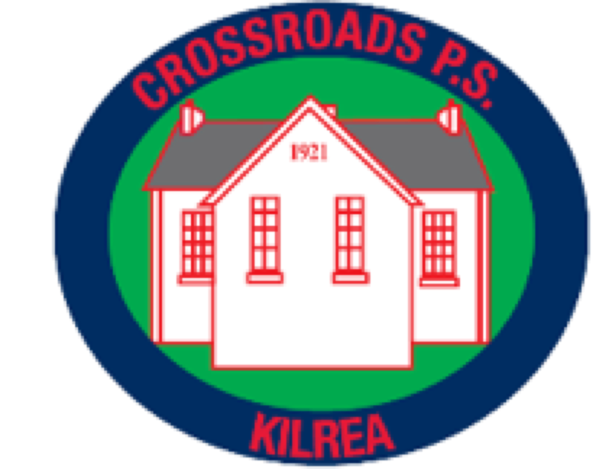

Crossroads Primary School

January 2021

Crossroads Primary School is committed to working in partnership with parents, all staff, Governors and wider community agencies to develop the health and well-being of all our pupils.

Introduction
It has been recognised that promoting healthy life styles assists in the process of raising levels of pupil achievement and promotes positive behaviour.

Aims of Health and Well-being in Crossroads Primary School

To promote the physical, social, mental and emotional health and well-being of all pupils.

To work with outside agencies in meeting the health and well-being needs of the whole school.

To engage parents and carers in our endeavours to promote health and well-being.

To encourage healthy eating habits among the children in our school.

This policy has links with other Pastoral Policies:

- Positive Behaviour Policy
- Anti-Bullying Policy
- Child Protection and Safeguarding Policy
- Health & Safety Policy
- Online Safety Policy
- Acceptable Use of Internet Policy
- Administering of Medication Policy
- Mobile Phone and Digital Devices Policy

School Ethos
We work together as a team at Crossroads Primary school to create a happy, positive, secure, inclusive and nurturing environment for every member of the school community. We have a child centred approach and are dedicated in ensuring that every activity has our children’s needs and interests as the first priority. We strive to develop the whole child – academically, emotionally, physically, spiritually and socially. We promote a Christian and nurturing ethos and aim to develop a culture of respect, fairness, cooperation, perseverance, self-discipline, forgiveness, honesty, kindness, acceptance and responsibility at all levels within the school. Our ethos is reflected in all areas of school life. We aim to promote relationships built on honesty, trust, respect and openness, ensuring everyone is valued and respected and feel a sense of belonging to our school where the efforts and achievements of all are celebrated. We believe that happy children, staff and parents are key to positive learning experiences and a successful school. We believe our ethos and values underpin the well-being of each member of our school community. Celebrating our children’s efforts and achievements in many forms in school with our school family and parents and on a wider scale in local/social media, develops within our children a sense of success and develops their self-esteem and confidence thus encouraging a positive sense of well-being.
Staff are committed to continuous personal self-development, improvement and providing a broad and balanced curriculum in a stimulating setting. Through effective, high quality teaching and learning, our goal is to develop independent, motivated and lifelong learners. Children are supported and challenged accordingly as they are encouraged to reach their full potential. We seek high standards of achievement and behaviour as we inspire every member of the school community to be the best they can be in all areas and succeed in fulfilling their own personal goals. We believe high standards and high expectations create within our children an innate sense of self-worth as they are encouraged to do their best and undertake activities matched to their interests and ability.
We are dedicated to providing opportunities for everyone to have a voice and listen respectfully to the views of others. Our children participate actively in the life of our school whether as a member of our school or eco council or in their role as Digital Leader etc. We also carry out regular surveys with our children to gain their feedback and often have informal chats to hear their views on school life.
We recognise and appreciate the important role parents play in their children’s education and we encourage them to be involved in the life of our school. We also value our parents’ input and feedback on school matters through regular questionnaires. We have an active PTA and enjoy parental support at many events throughout the year whether social events or events aimed at sharing information with our parents. We appreciate parent volunteers assisting in various areas of school life.
We are proud of our area and aim to be a school that has Crossroads and its people at the core. It is our vision to see our school grow in the community as we provide increasing opportunities for our children to participate, contribute, value and take pride in their local village as they do their school.

The School Curriculum

In Crossroads Primary School the children are taught about healthy living in order to equip them with the skills, knowledge and understanding that will enable them to live positive, successful and healthy lives. Throughout the various year groups, children receive visits from various members of the medical profession in order to promote good oral hygiene and good health. Often these visits form part of their WAU learning or as a result of learning through ‘Keeping Healthy’ in PDMU lessons using the Living Learning Together resources and activities. The children are also kept aware of health and well-being issues through visits from dairy council, childline, nspcc and attendance at BEE SAFE events run through Mid Ulster council. We have displays around school that display and celebratee children’s work as well as portray important messages on health and well-being. PDMU displays are also evident in every classroom. Children also receive visits form the Fire Service NI, PSNI and Farm Safety to educate on the dangers presented e.g. stranger danger, online safety, firework safety etc.

As well as physical well-being the school promotes emotional well-being though PDMU, use of social stories, circle time and role-play scenarios where situations are addressed. Conflict and resolution scenarios are discussed and worry boxes exist in all classes along with calm corners in younger classrooms when they are needed. Children with ASD or additional needs have specific measures put in place to assist them to get the most from school life. Growth and mindset activities have been adopted throughout the school in order to promote a positive mindset amongst our pupils. Through our school values we promote encourage pupils to try their best. Class rewards (as outlined in our behavior policy) also promote emotional well-being as children are rewarded for effort and progress in all areas of school life.
In developing the whole child, we recognise the importance of teaching children to express how they are feeling as their emotional well- being is vitally important in their development both socially and academically.
Classrooms are busy environments and for some children provide too much sensory stimulation which may result in anxiety or behavioural outbursts. Class teachers incorporate regular brain breaks into their daily routines and self -regulation is encouraged through breathing and grounding exercises. Individual pupils may need short breaks out of class at certain times to help with concentration and to cope with difficult situations
In order to meet the needs of all our children, staff receive regular training. We have implemented advice from R.I.S.E. Behavioural Support and Autism Advisory and Intervention Support Services. Regular communication is in place with parents and a specific programme of work/ individual education or behaviour plans are also drawn up alongside pupils and parents to help address any concerns and to provide suitable support.
Spiritual well-being is promoted though our Catholic ethos, participation in the Grow in Love Programme across the school and maintaining close links with our parish priest Fr Cargan and visits to mass.

Healthy Breaks

In Crossroads Primary School healthy breaks are promoted. The children are encouraged to eat a portion of fruit along with milk or water. Alternatively, they can purchase toast, bagel, wheaten bread/ fruit in the school canteen. The children are encouraged to take water into class to drink throughout the day to stay hydrated.

School Meals

The importance of health education in the curriculum is reinforced by the canteen staff, who serve highly nutritious meals. Free milk/ water is provided with school dinners.

All kitchen / school staff value positive relationships with the children and there is a positive and happy atmosphere amongst pupils and staff during lunchtime! Children can also bring a healthy packed lunch to school.

Children with special dietary needs are also catered for. Parents advise the school of any requirements and a meeting with the principal and kitchen personnel ensure all needs are met effectively. Crossroads Primary School is also a nut free zone.

Transition

In Crossroads Primary School we realise the importance of effective transitions between our school and our local pre-schools and post primary schools. As a result, to ensure this change is as smooth as possible for pupils we maintain effective links with our local schools:

Pre-school children from Kilrea Early Years are invited to school as part of our induction programme.

Annual induction programme with ‘All About Me’ booklet issued so our staff can learn about new starts.

Open evening and appointments for potential new starts with play session, tour of school and prospectus provided etc.

Phased start in September for new P1 children to adopt new routines

Buddies assigned at Induction (older children linked with P1) who maintain effective relationship with P1 children for the whole year as they meet weekly to read with them, play games etc. (2021-2022)

Links with post-primary schools e.g. workshops, open days etc

Promotion of open evenings and visits from post- primary school staff members

Playground

We have a system in place in the playground at break and lunchtime where older children are trained as playground buddies and help younger children playing games, socialising and helping them feel secure outside. Lunchtime supervisors have undergone training in lunchtime routines and also participate in playing games with children. During break and dinner all children must go outdoors - weather permitting. All pupils are continuously encouraged to wear their coat outdoors. Children are permitted to stay indoors only if written consent has been given by parents.

Behaviour

High standards of behaviour are expected in Crossroads Primary School and every

member of staff is committed in promoting this. School council members are also heavily involved in promoting positive behaviour and rewards and sanctions are outlined in our Behaviour Policy. A positive behaviour system is in place in each classroom to promote good behaviour with motivators changed regularly. High standards are expected inside and outside the classroom – any incidents of bullying will be taken seriously and dealt with in accordance to our Anti-Bullying Policy. Anti-bullying is addressed frequently throughout the year in assemblies and also in PDMU sessions in class. A theme is adopted during Anti-Bullying week every year and this is shared with parents.

Educational Outings

Crossroads Primary School takes children on school outings outside of the classroom that will stimulate learning and promote enjoyment. Termly educational trips related to WAU topics take place for each year group as well as fun trips at Christmas and end of year. We organize an annual residential trip to an Outdoor Education Centre for primary 7 to help children develop in independence, as well as socially, physically and emotionally. A risk assessment is carried out prior to all trips and parental consent approved.

Safety of Children

The school is equipped with a security door at front and rear. Security locks are on during the school day and anyone wishing to gain entry to the school must press the buzzer. Only a member of staff will permit entry to the building, children are not allowed to open the doors. Visitors to the school sign in and wear a school visitor badge. Parents inform school if there is any change in person picking a child up or if arrangements change.

Bee Safe/ Radar

The Primary 7 pupils have the opportunity to take part in the Bee Safe Programme. Bee Safe is an imaginative way of teaching Primary 7 pupils to prevent everyday accidents and dangerous situations and how to deal with them safely if they occur. They are usually invited to RADAR in Belfast annually as well.

Medication
If a child requires urgent medication during the school day, parents should inform the
class teacher. Parents can visit during break or lunch time to administer medication or give written consent for school to administer it. Parents are issued with medical information forms which are updated annually. (See Administering of Medication Policy)

Online Safety

Online Safety has become a major focus for us in Crossroads Primary School and this also is addressed frequently throughout the year.
We regularly use the Internet in school. In order to minimise the risk of children coming across unsuitable material, we provide constant supervision, and we use only a filtered service, selected links, and child- friendly search engines. Parents/ pupils are asked to sign authorisation for their child to use the Internet. We also seek parental permission before using photographs of children or their work on the school’s website, or in newsletters and other publications.

A preventative curriculum is taught on online safety and pupils are made aware of the dangers that can exist through inappropriate contact, conduct and content as well as a yearly visit from the PSNI and attending Bee Safe/ Radar Events. Parents are also advised through newsletters, assemblies which they are invited to attend, online safety evenings in school etc. (Please see our Online Safety Policy).

Active School Travel

We are an Active Travel School as part of Sustrans NI and are currently working towards our silver mark. This initiative promotes healthy and active lifestyles through active travel. Every year we participate in the Big Pedal. Most of our active travel initiatives are playground based as the road outside school is much too busy and dangerous to expect active travel. Other events promoted are ‘Ditch the Dark,’ ‘Ditch the Stabilisers,’ and also children undergo cycling training as well as cycling proficiency to enable them to ride to school safely. We also participate in the daily mile.

Outdoor Learning

All children throughout the school have the opportunity to use the school’s outdoor areas. Outdoor learning has many benefits for children’s health and well-being. Children have the opportunity to develop motor skills and co-ordination. It also helps develop a life-long good habit of daily exercise. The benefits of exercise and outdoor play are continuously addressed in class and in monthly assemblies. Weekly safety checks of our outdoor play facilities are carried out by a member of staff and dealt with accordingly. Older children also take part in outdoor learning sessions which links to all areas of the curriculum.

Forest Schools NI
Crossroads have registered to embark on their journey to become an affiliated Forest School in 2022-23. Mrs. McKeown is leading the initiative although all teachers and pupils in all classes will be involved. "Forest School" is based on a Scandinavian idea that considers children's contact with nature to be extremely important from an early age. We are invested in improving our outdoors experiences for our pupils.

Physical Education/ After School Clubs

Physical Education helps children develop positive attitudes to participation in Physical Activity. Throughout the year the children have the opportunity to participate in two weekly sessions of Physical Education including dance, athletics, gymnastics and games. Coaching is also available for children after school in Football, Camogie, soccer, dance. Pupils from P4- 7 also have the opportunity to participate in weekly swimming lessons for the year. We encourage participation in sporting events and tournaments as well as our annual Sports Day.

Parental Links

We have a very supportive body of parents in Crossroads Primary School and participation is encouraged in all areas of school life.

Workshops are also provided for parents from time to time e.g. the internet safety workshop, phonics workshop, mental maths workshop as well as information sent home to support children’s learning e.g. termly topic letters, leaflets on Numeracy and Literacy.

The Class Dojo App is also used to keep parents up to date on school matters, pupil progress and well-being.

Health and Well-Being of Staff

The health and well-being of staff is equally as important in our school. In order to ensure that staff feel valued and appreciated various strategies are in place. For example, their opinion is often sought through the use of surveys and also through regular staff meetings and opportunities to discuss school practice. Numerous occasions to celebrate and socialize are organized.

All staff have opportunities to avail of training (often as a result of self-evaluation) so they feel confident and well-equipped to deliver within their role. All staff are also aware of INSPIRE WORKPLACES and the support they offer.

We have a mental health champion in place within school. Miss McErlean (primary 7 principal relief teacher currently holds the role)

