COMPLAINTS PROCEDURE
Crossroads Primary School

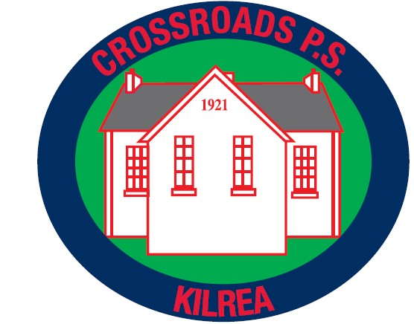

December 2017

Contents
Foreword
Aims of Complaints Procedure
School Complaints Procedure – at a glance
Scope of Complaints Procedure
What to expect under this Procedure
Making a complaint

Foreword

Ethos

Crossroads Primary School aims to promote a safeguarding ethos which permeates all aspects of school life. Our educational environment is tailored to suit the needs of all of our pupils.

The motto of Crossroads Primary School is “Inspiring children to be the heart and future of our community.” Indeed, the ethos of Crossroads is that of a Catholic school where the partnership of the home, school, parish and extended family are of paramount importance.

More recently, as a staff, we have added three important words that represent our aim as we come to school each day. We feel it complements the values and ethos of our school perfectly.

NURTURE - INSPIRE - FLOURISH

We place a great deal of emphasis on our partnership with parents. We believe that children learn best when home and school work together for their benefit. The policy of our school is to share positively with parents in creating a safe and caring environment where each child may reach their full potential in every aspect of their growth. It is our aim to build on these skills and promote a willingness and enthusiasm to learn more. Our school values very highly the feedback and opinions of all stakeholders including pupils, staff, parents and governors. We are respectful of all who come through the door of our school and on an occasion where a complaint may arise we will do our best to deal with it early and in the most professional manner possible. Where a parent or member of the school community has an issue, we encourage dialogue with staff as early as possible rather than allowing potential issues to develop further. If concerns are dealt with at an early stage, then they are more likely to be resolved and there is no unnecessary dissatisfaction.

It is possible to speak with any member of teaching staff by making an appointment through the school office. Alternatively, times which are mutually convenient can be arranged face to face with teachers where appropriate.
If you have any issues, please talk to the teacher. Concerns about matters other than in the classroom should be raised with the Principal. We take all concerns seriously and make every effort to resolve matters as quickly as possible.

AIMS
When dealing with complaints the school will;
- encourage resolution of all concerns as quickly as possible
- provide timely responses to concerns and complaints
- keep you informed of progress
- ensure a full and fair investigation of your complaint where appropriate
- have due regard for the rights and responsibilities of all parties involved
- respect confidentiality
- fully address complaints and provide an effective response
- take appropriate action to rectify the issue and prevent it happening again where appropriate
- be responsive to learning from outcomes which will inform and improve practice within the school.

A copy of this Procedure is available on the school’s website or is available from the school on request.

Complaints Procedure – At a glance
Stage Two
Write to the Chairperson of Board of Governors

Stage One
Write to the School Principal
Time Limit
Please contact the school as soon as possible, unless there are exceptional circumstances, complaints will normally only be considered within 6 months of origin of the complaint to the school.
Stage One
When making a complaint, contact the school Principal who will arrange for the complaint to be investigated. If the complaint is about the Principal, proceed to Stage Two. The school requires complaints to be made in writing, where this may present difficulties, please contact the school which will make reasonable arrangements to support you with this process. (see guidance notes for further information),
Please provide as much information as possible including;
- name and contact details
- what the complaint is about
- what has already been done to try to resolve it and
- what you would like the school to do to resolve the complaint.

The complaint will normally be acknowledged within 5 school working days and a response normally made within 20 school working days of receipt of the complaint. This response will be issued in writing by the Principal and will indicate with reasons whether the complaint has been upheld, partially upheld or not upheld.
These timeframes may be different if complaints are ongoing during school holiday periods.
If you remain unhappy with the outcome at Stage 1, the complaint may be progressed to Stage 2 which is overseen by the Board of Governors.

Stage Two
If the complaint is unresolved after Stage One, write to the Chairperson of the Board of Governors (care of the school and marked ‘private and confidential’). Where this may present difficulties, please contact the school which will make reasonable arrangements to support the complainant with this process. The Chairperson will convene a committee to review the complaint. Please provide as much detail as possible as indicated above.
The complaint will normally be acknowledged within 5 school working days and a final response normally made within 20 school working days from date of receipt of the complaint. The response will be issued in writing by the Chairperson of the committee.
These timeframes may be different if complaints are ongoing during school holiday periods.
Northern Ireland Public Services Ombudsman (NIPSO)
If following Stage Two you remain dissatisfied with the outcome of your complaint, you can refer the matter to the Office of the Northern Ireland Public Services Ombudsman (NIPSO).
The Ombudsman provides a free, independent and impartial service for handling complaints about schools in Northern Ireland. You have the right to complain to the Ombudsman if you feel that you have been treated unfairly or have received a poor service from a school and your complaint has not been resolved to your satisfaction.
A complaint should normally be referred to NIPSO within six months of the final response from the School. The school must advise in its concluding letter that the complaint may be referred to the NIPSO if you remain dissatisfied.
Contact details for NIPSO are:
Northern Ireland Public Services Ombudsman
Office of the Northern Ireland Public Services Ombudsman
Progressive House
33 Wellington Place
Belfast
BT1 6HN
Freepost: FREEPOST NIPSO
Telephone: 02890 233821
Freephone: 0800 34 34 24
Email: nipso@nipso.org.uk
Web: www.nipso.org.uk 8

1. SCOPE OF COMPLAINTS PROCEDURE
1.1 The Complaints Procedure sets out how any expression of dissatisfaction relating to the school will be managed. By taking concerns raised seriously at the earliest possible stage, it is hoped that issues can be resolved quickly and effectively.

Some examples of complaints dealt with;
- not following school policy
- communication delays / lack of communication
- difficulties in staff / pupil relationships.

1.2 Complaints with separate established procedures
Some examples of statutory procedures and appeal mechanisms are listed below. The list is not exhaustive. The Principal/ Chair of Governors will advise on the appropriate procedure to use when the complaint is raised.
Matters may still be referred to NIPSO, if it is felt that maladministration has occurred. Exceptions | Contact
• Admissions / Expulsions / Exclusion of children from school  • Statutory assessments of Special Educational Needs (SEN)  • School Development Proposals  • Child Protection / Safeguarding | Contact www.eani.org.uk Director of Operations and Estates  Sara Long  Contact www.eani.org.uk Director of Children and Young People’s Services Dr Clare Mangan  Contact www.eani.org.uk Director of Education  John Collings  Contact www.eani.org.uk Director of Children and Young People’s Services  Dr Clare Mangan

